RRDtool绘图——graph参数使用之经典实例
看了一些讲RRDtool绘图命令graph用法的文章，有些版本过时，命令不同了，还有些就像我前边写的“Hello World”里边的作图一样，泛泛带过，针对性不强。这里献给大家两个自认为经典的例子，希望对大家有帮助：）ps：如果自己操练，改与数据库相关的就 ok了。
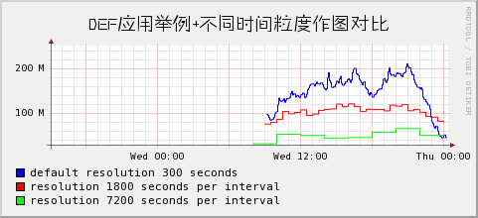
实例1：DEF提取数据＋理解时间粒度（间隔）对作图的影响。
rrdtool graph def.png \
--end now --start end-120000s --width 400 \
-t "DEF应用举例+不同时间粒度作图对比" \
--font TITLE:14:FZZHYJW.ttf \
DEF:dsa=/home/rrdtool/data/router1.rrd:dsa:AVERAGE \
DEF:dsb=/home/rrdtool/data/router1.rrd:dsb:AVERAGE:step=1800 \
DEF:dsc=/home/rrdtool/data/router1.rrd:dsc:AVERAGE:step=7200 \
LINE1:ds0a#0000FF:"default resolution 300 seconds\l" \
LINE1:ds0b#00CCFF:"resolution 1800 seconds per interval\l" \
LINE1:ds0c#FF00FF:"resolution 7200 seconds per interval\l"
出图：
实例2：VDEF、CDEF用法＋坐标轴标签＋横纵线条＋报告生成＋更新时间
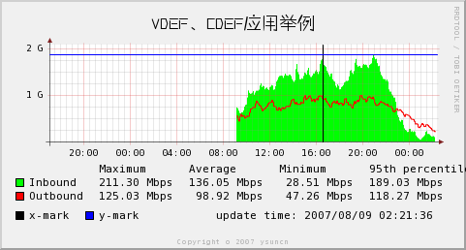
rrdtool graph graph.png \
--end now --start end-120000s --width 400 \
-t "VDEF、CDEF应用举例" \
--font TITLE:14:FZZHYJW.ttf \
--x-grid MINUTE:30:HOUR:4:HOUR:4:0:%H:%M \
# 每30分钟一条线，每4小时一条主线，4小时一个标签标于主线下方，标签格式“小时:分钟”
-Y \
DEF:ds0=/home/rrdtool/data/router2.rrd :Inbound :AVERAGE \
DEF:ds1=/home/rrdtool/data/router2.rrd :Outbound:AVERAGE \
VDEF:ds0max=ds0,MAXIMUM \
VDEF:ds0avg=ds0,AVERAGE \
VDEF:ds0min=ds0,MINIMUM \
VDEF:ds0pct=ds0,95,PERCENT \
VDEF:ds1max=ds1,MAXIMUM \
VDEF:ds1avg=ds1,AVERAGE \
VDEF:ds1min=ds1,MINIMUM \
VDEF:ds1pct=ds1,95,PERCENT \
CDEF:ds0bits=ds0,8,* \
CDEF:ds1bits=ds1,8,* \
COMMENT:" " \
COMMENT:"Maximum " \
COMMENT:"Average " \
COMMENT:"Minimum " \
COMMENT:"95th percentile\l" \
AREA:ds0bits#00FF00:"Inbound " \
GPRINT:ds0max:"%6.2lf %Sbps" \
GPRINT:ds0avg:"%6.2lf %Sbps" \
GPRINT:ds0min:"%6.2lf %Sbps" \
GPRINT:ds0pct:"%6.2lf %Sbps\l" \
LINE1:ds1bits#FF0000:"Outbound" \
GPRINT:ds1max:"%6.2lf %Sbps" \
GPRINT:ds1avg:"%6.2lf %Sbps" \
GPRINT:ds1min:"%6.2lf %Sbps" \
GPRINT:ds1pct:"%6.2lf %Sbps\l" \
COMMENT:"\s" \
VRULE:1186562026#000000:x-mark \
HRULE:1700000000#0000FF:y-mark \
COMMENT:" update time\: `date \"+%Y/%m/%d %H\:%M\:%S\"`" COMMENT:"\l"
出图：

